Ansible Documentation

Ansible Inventory:

2.

3.

4.

5.

6.

7.

YAML :

Ansible Playbooks:

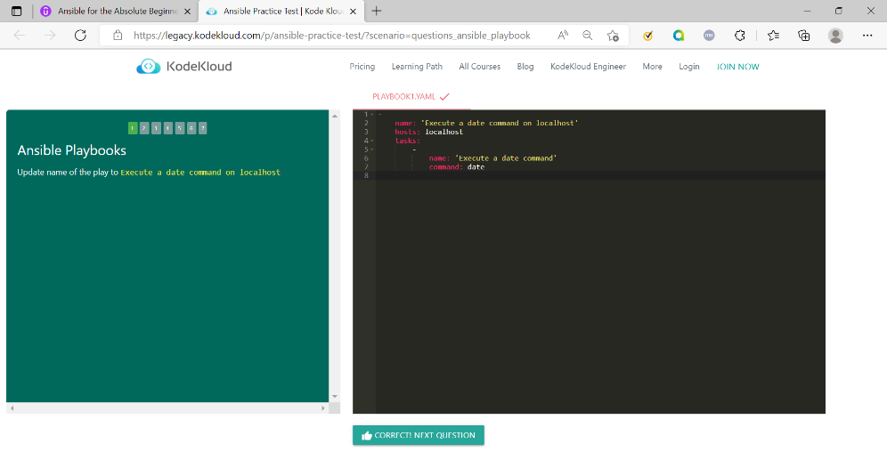

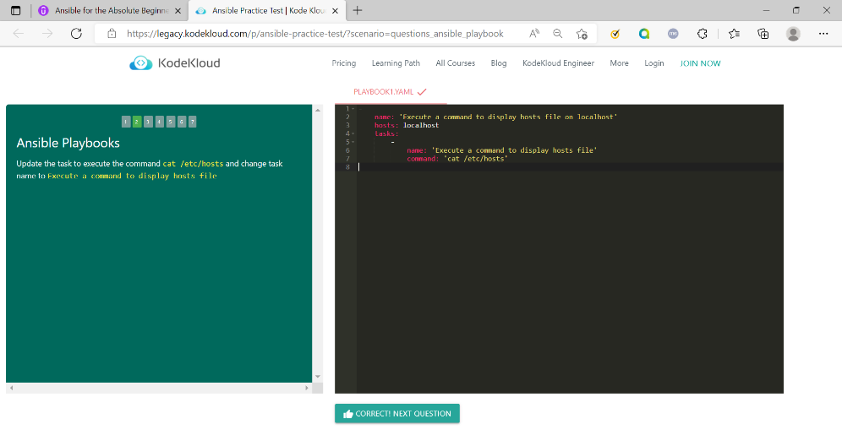

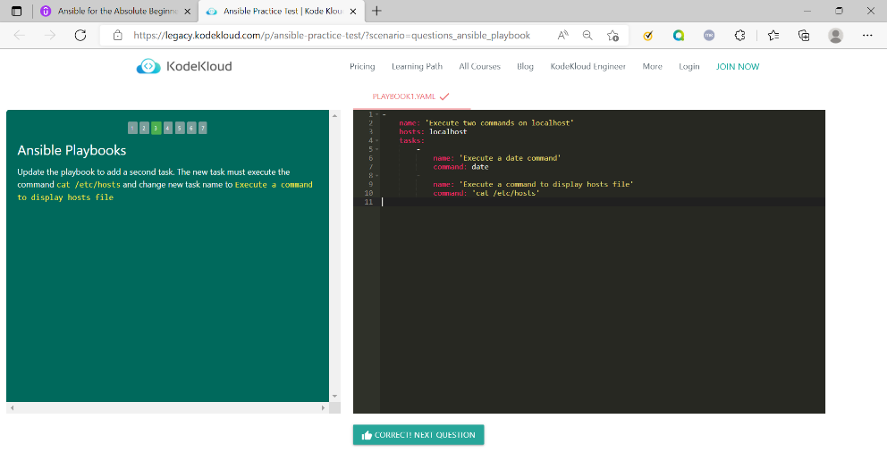

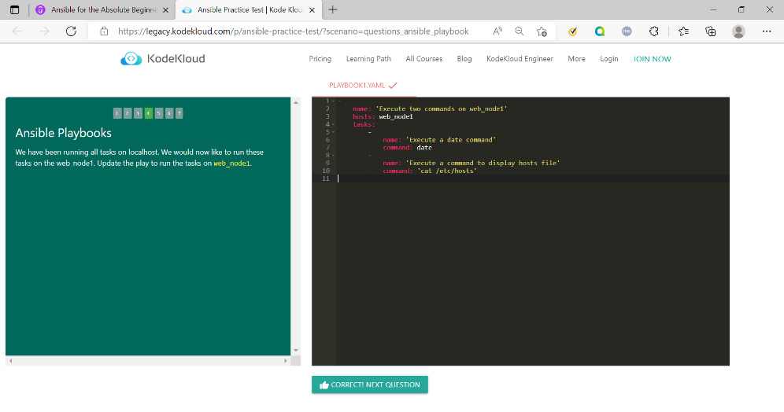

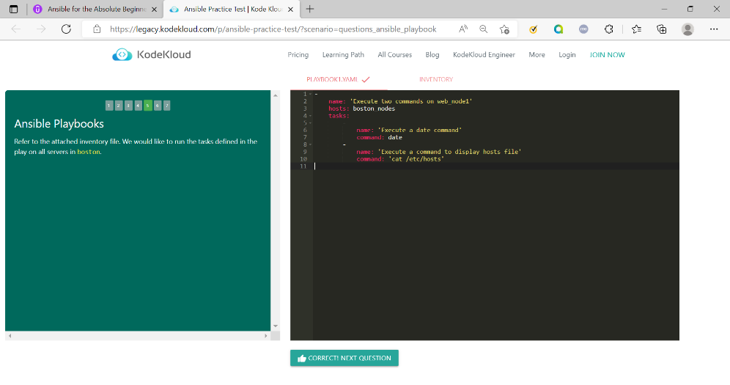

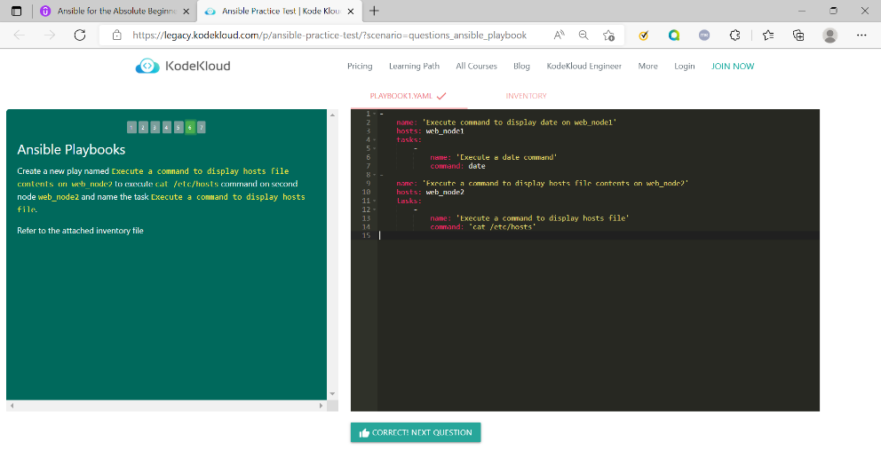

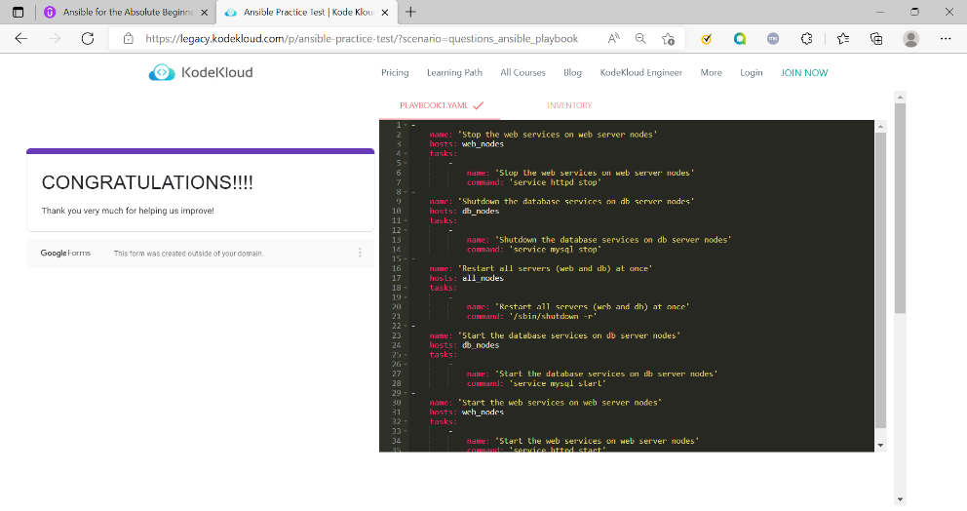

Ansible Modules:

Ansible Variables:

Ansible Conditionals:

Ansible Loops:

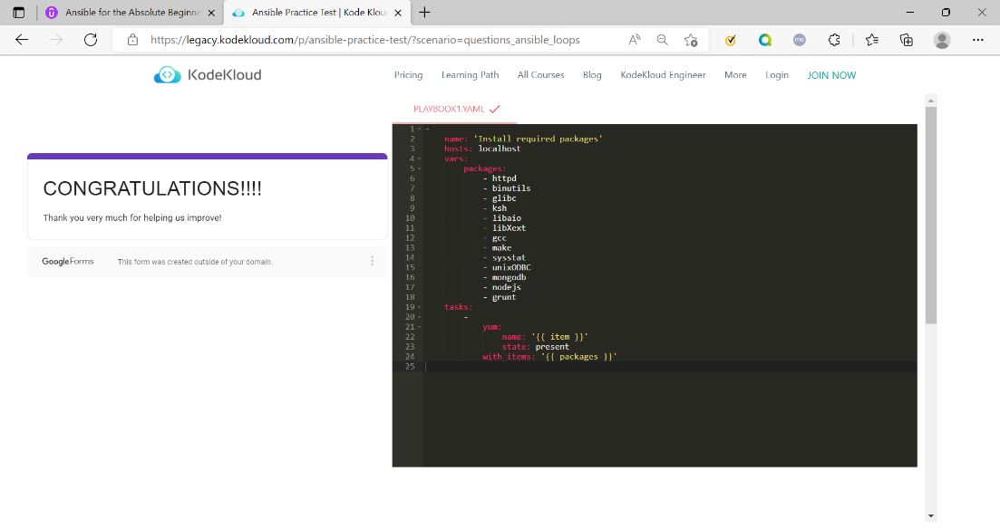

Course Completion Certificate:

